St. Marys Primary School
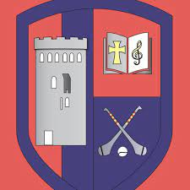
www.stmarysprimary.ie
info@stmarysprimary.ie.
Term 1
Newsletter
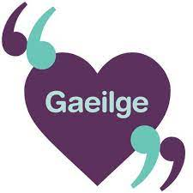

Gaelbhratach: Irish Flag
Last year we started our journey on further promoting the speaking of Irish informally within our school community. We successfully completed the targets for year 1 and obtained our Gaelbhratach Certificate. Well done to all our pupils on their participation and achieving this for their school. This year we will maintain these targets as well as work towards completing new targets, in an effort to win an Irish flag for our school.
Gaelbhratach explained.
Gaelbhratach is a scheme which supports and encourages schools in their efforts to promote the Irish language. The scheme is open to schools at both primary and secondary level. Schools are awarded the Gaelbhratach upon successful completion of a variety of targets. The primary aim of the scheme is to create and encourage a culture of speaking Irish informally within the school community and beyond.
The scheme is operated and coordinated by Gael Linn with support from Conradh na Gaeilge and Glór na nGael. Gaelbhratach is funded by Foras na Gaeilge with support from the Department of Education.
Some of the areas we will add emphasis on this year are:
- Rhymes, Songs, Clapping, skipping and Circle Games. This target will be carried out by every class at a level which is suitable for them. There is a wealth of language to be learned from these phrases and vocabulary as well as the sounds and rhythm of Irish. This will be linked to School Assembly or Games or Buddy System when a senior class would help the younger pupils.
- Karaoke in Irish with Irish song on a regular basis
- Buddy System – on an ongoing basis Pupils from senior classes working with pupils from junior classes through the medium of Irish – See Assembly and Story session, Playground games, circular games with rhymes etc.
We will continue to circulate our Irish games throughout the school every week, focus on specific conversational Irish phrases each month which will be read out by pupils on the intercom, encourage displays of Irish work in our hall and classrooms, nominate welcomers to welcome children to the class each day, participate in Seachtain na Gaeilge where the Irish language will be celebrated through performances and enjoyable activities for the pupils over a period of two weeks and conduct surveys with the pupils gathering information on where they can see Irish in the school community and where it could be added.
We thank the pupils on all their great efforts made with this initiative!

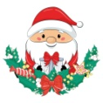
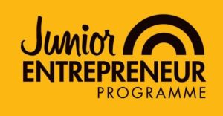

Junior Entrepreneur Programme

Mr. Shanahan's 5th class are taking part in the Junior Entrepreneur Programme this year. Through JEP pupils get a clear picture of what creating a business is all about. The programme is designed to integrate into the primary school curriculum, with each step providing opportunities for pupils to learn new life skills in addition to comprehensively covering their core subjects. The learning that takes place during JEP will give children a greater understanding of many things that happen in the real world. They will get to understand how the value of goods and services is created and how skill, talent and creativity can create more than the sum of their parts in an entrepreneurial enterprise. Our product is top secret at the moment! We hope to hold a Toy sale in January in order to raise money to fund our project. Details will follow early in the New Year!

Green Schools News
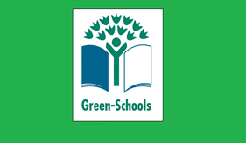
We are delighted to be partaking in a new Green Schools Theme this year. We are learning about Global Citizenship Food & Biodiversity. Classes will have the opportunity to learn about biodiversity and to grow some of their own produce. It is a very exciting time and we can’t wait to get stuck in.
As part of our seasonal programme of activities, we held our very successful recycled Christmas Decoration Competition. We had hundreds of entries. This competition encourages us to make a Christmas decoration from recycled material only. The standard was really high as always. We held an exhibition in the school hall so that all classes could see and admire our hard work. Everyone who took part was awarded a certificate. It is wonderful to see the creativity in the school. A huge thank you to all of the parents for their support. It is very much appreciated. See photographs below of a selection of the entries.
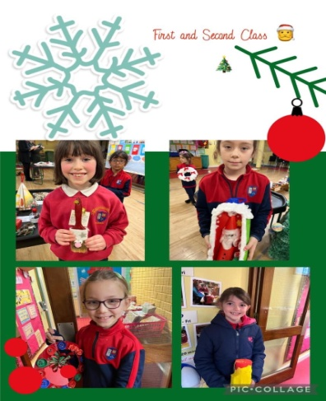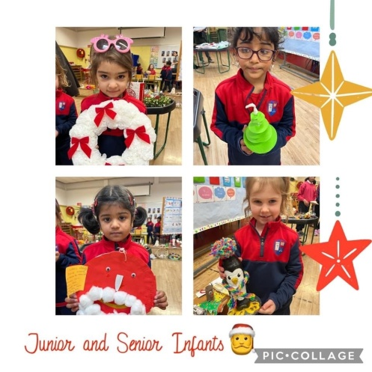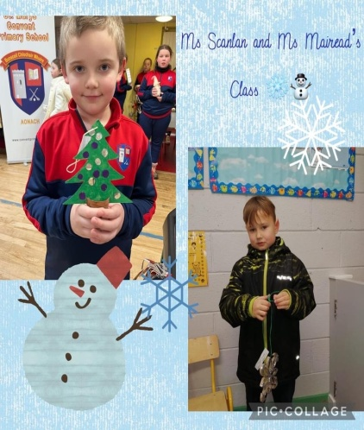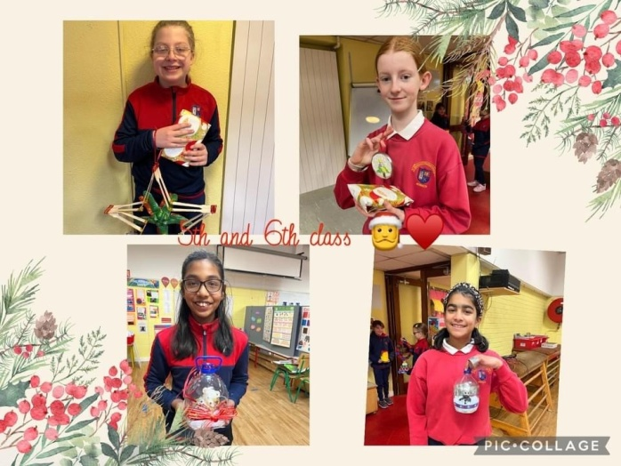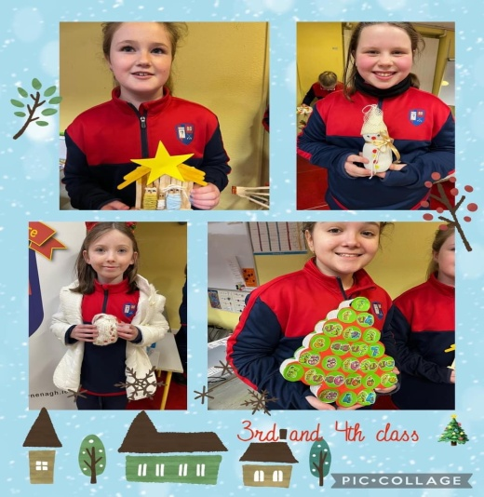

Peace Proms
St. Mary’s will perform in the Limerick Peace Proms in January 2023. Ms. Mary Ryan’s third class will represent the school, having attended their first choir workshop in the University of Limerick on November 15th. They are delighted to celebrate culture, diversity and promote peace, unity and tolerance through music. The girls will sing with a choir, perform with a full symphony youth orchestra and work with one of the UK’s leading professional conductors Mr. Greg Beardsell.

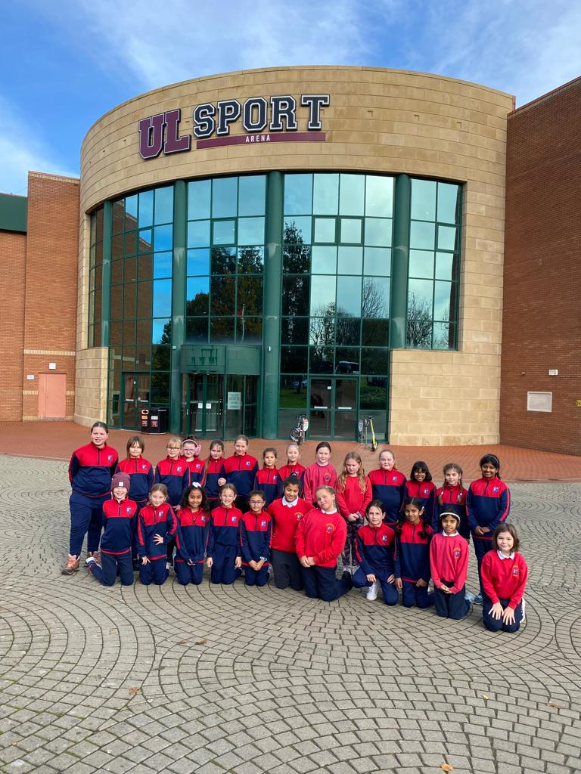

Primary Language Sampler
Both fourth class pupils began the new Primary Language Sampler which is a means for raising awareness among pupils of the range of languages used by their peers, in their schools and community. The module introduced the pupils to the French language and was thoroughly enjoyed by all. Vive la France! Bravo á tous les éleves.

Science and Maths Week 2022
Both Maths and Science Weeks were celebrated in October throughout the school and all STEM related activities were well documented across our social media platforms.
Participation in Maths week included the development of several Maths trails around the school, and engaging in Maths focused activities e.g. Mathletes Challenge, Mangahigh and MathsEye. Pupils also applied Maths in practical ways to help explore and solve real world problems. Sixth class students participated in the I’m a Mathematician student-led STEM enrichment activity, where students engaged with Mathematicians in real-time text based chats.

Science Week included lots of hands on investigations from the four science curriculum strands, Students participated in Science events online, they attended Science shows at Nenagh Arts Centre and Nenagh Library in conjunction with Tipperary Science Festival. Senior classes were skyping and interviewing scientists. There was also an in person visit to the Science Foundation of Ireland Discovery Centre, the National Stud in Kildare by Ms. Spaight’s fourth class on 0ctober 27th.

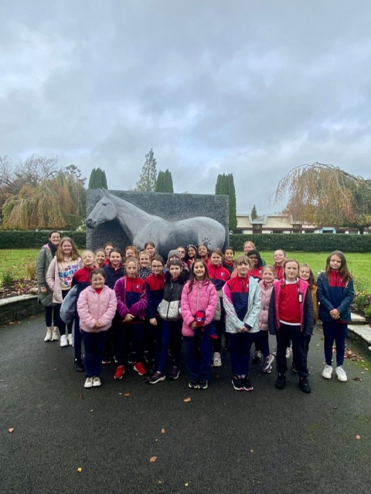

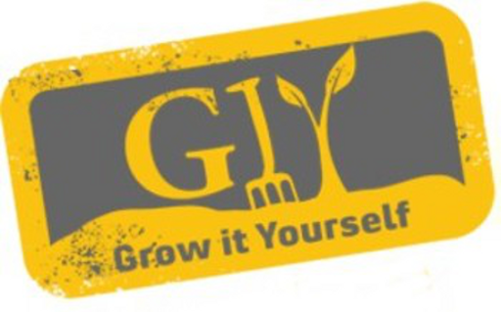

Grow It Yourself Update
Ms. Mary Ryan's 3rd class have been busy this term taking part in the GIY Grow It Yourself programme. We prepared our polytunnel for planting garlic and onion bulbs. We researched the website www.giy.ie for tips and tricks in preparing the soil bed, tending to the bulbs and maintaining the polytunnel. We look forward to harvesting our garlic and onions in Springtime and also to receiving our next delivery of seeds for our spring planting!

School Carol Service
We would like to take this opportunity to thank our pupils, parents and staff for the wonderful work done by all to make the evening of our carol service such a great success. The voices of the pupils filled the church and it was fantastic to see so many families there. Everyone really enjoyed the whole event and it was a great showcase for our talented pupils.

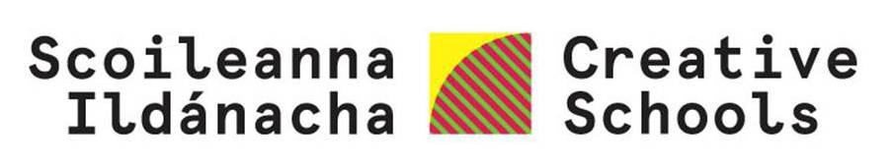
St. Mary’s is delighted to have been accepted onto the Creative School’s Ireland Programme, led by the Arts Council of Ireland. Creative Schools is the flagship initiative of the Creative Ireland Programme to enable the creative potential of every child. We have been assigned a ‘Creative Associate’ Joanna Parkes, who will work with the school to develop an individual school plan to develop and foster creativity within the school. Joanna, will be starting her work with us in January and we are really looking forward to getting started on our journey!

Thank you
Thank you to all of the parents/guardians of our pupils for all of your support and cooperation this year.
Wishing you and your families a happy, healthy and peaceful Christmas & New Year. School will reopen on Thursday January 5th 2023. We look forward to welcoming our pupils back then.
