St. Marys Primary School
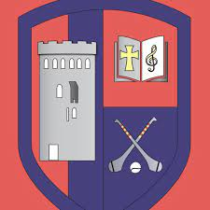
www.stmarysprimary.ie
info@stmarysprimary.ie.
Term 1
Newsletter
Green Schools News
We have been doing a lot of work on the Global Citizenship Travel Theme. We are hoping to achieve our ninth green flag this year. Every class has been learning about methods of sustainable travel. We had a very important visitor to the school. Ellen O’ Sullivan Travel Officer with An Taisce came to the school to carry out a Walkability Audit for our school and to chat with us about what we had learnt. She met with our Green Schools Committee and we undertook some speed and noise surveys outside the school. Each class has been working on their own ‘Green Code’. Some fantastic suggestions were compiled by Ms. O’ Toole’s fifth class. We had hundreds of entries into the Christmas Decoration Competition this year. This competition encourages us to make a Christmas decoration from recycled material only. The standard was really high as always. We held an exhibition in the school hall so that all classes could see and admire our hard work. We are exhibiting some of our decorations in the local library so that they can be admired also by the public. We would like to remind parents to switch off their engines around the school as part of our no idling campaign. Did you know that idling cars have a negative impact on the air quality outside our school as well as adding to congestion. The Green Schools Committee have been working hard on the application for our ninth green flag. We hope to have some good news to share before too long.
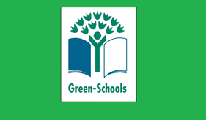
Food Dudes in St. Mary’s
St. Mary’s are delighted to have participated in the Food Dudes programme this term. Food Dudes is designed to encourage children to eat more fruit and vegetables both in school and at home. It is based on positive role models (the Food Dude characters), repeated tasting and rewards. Food Dudes aims to maintain long term fruit and vegetable consumption and extends to the home, whereby children are encouraged to bring their own fruit and vegetables to school every day. Working together, we can promote healthy eating and thus help our children to make more informed food choices as they grow up.
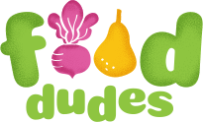
Recent Events in St Mary’s

- We are thrilled to launch our Coiste na Gaeilge initiative. We are encouraging all of the children to get involved in using their Gaeilge as much as possible in fun interactive ways.
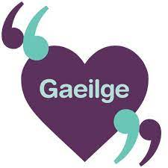
- We have been very busy taking part in the Active Schools initiative. We are doing lots of daily movement breaks in our classes and are very much looking forward to participating in the ‘Reindeer Dash’ on Friday.
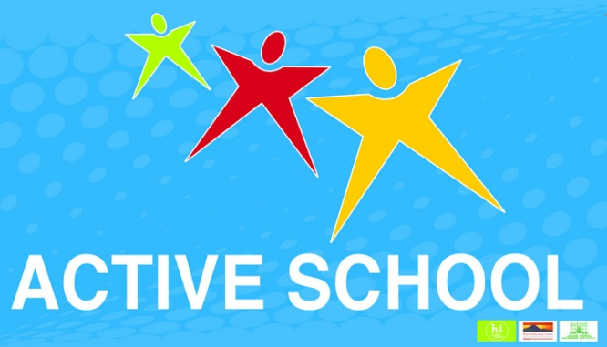

- St. Mary’s was extremely proud to have raised €620 from our recent ‘Crazy Hair Day’ which we presented by the Student Council to Harry Martin from St. Vincent De Paul. The proceeds will go towards providing help in our local community. Well done everyone!
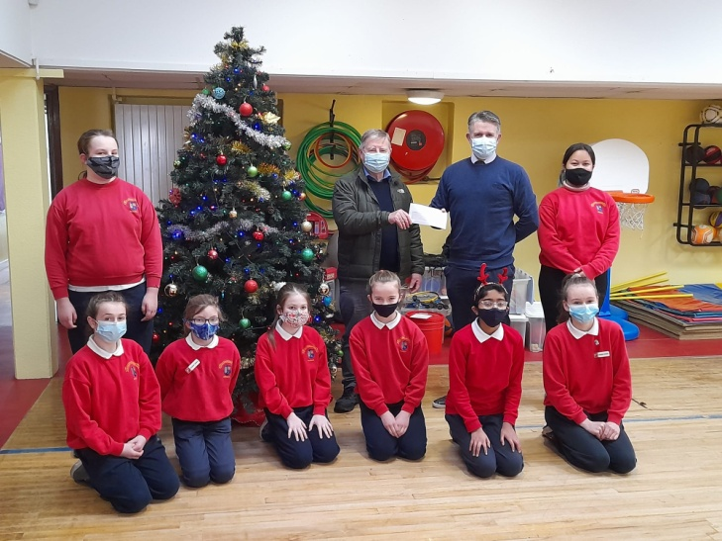
- During Mission Month, the pupils participated in GOAL Jersey day, raising much needed funds for a worthy charity, committed to helping people and communities left devastated by natural disasters.
- In October, the whole school community came together in the school grounds to celebrate Children's day of prayer, and to pray for children throughout the world.
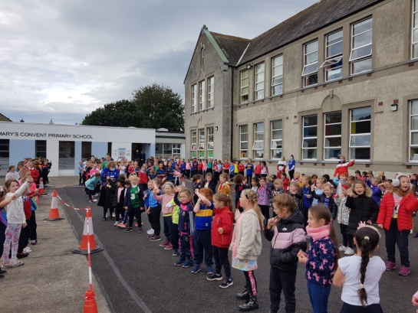
- Our wonderful new website has been launched. It is great to see high numbers of parents logging on to see some of the fantastic work taking place in our classrooms. The web address is www.stmarysprimary.ie . Check out our school on facebook also.
- Friday December 17th will be a festive Fun Day for the children. The children will come to school in Christmas clothes and be asked to donate €2 on the day. They will get to view The Helix Panto- Red Riding Hood in their classes. The Reindeer Dash will take place. It should provide a colourful Christmas spectacle, with the children in their festive clothes. It is intended for the day to be a welcome release for all.
Snapshots into some of our classes
Ms. Forde’s Fifth Class
- 'Fifth class have had a busy but exciting first term here in St. Mary's Primary School. From studying the ancient Maya tribe to thinking of a career in computer science with our coding projects; there has been endless fun and learning. Many thanks to Pamela O'Brien for facilitating our coding sessions. Fifth class girls have shown their creative sides when sewing Halloween monsters and making recycled and clay Christmas decorations. A highlight of the first term has certainly been our Active Breaks which all students enjoy. Wishing you all a lovely Christmas and a happy and healthy New Year, 5th class St. Mary's Primary.'
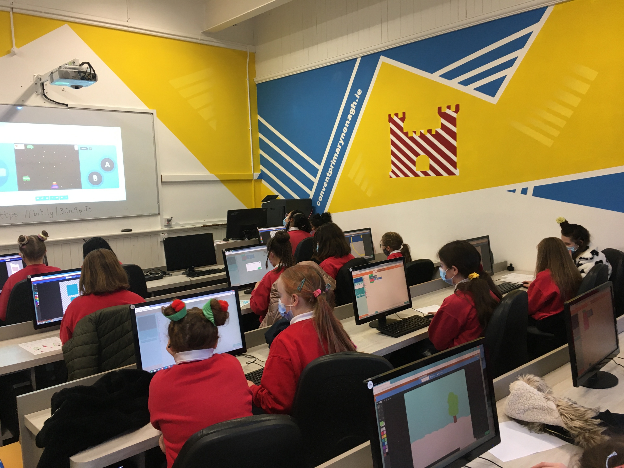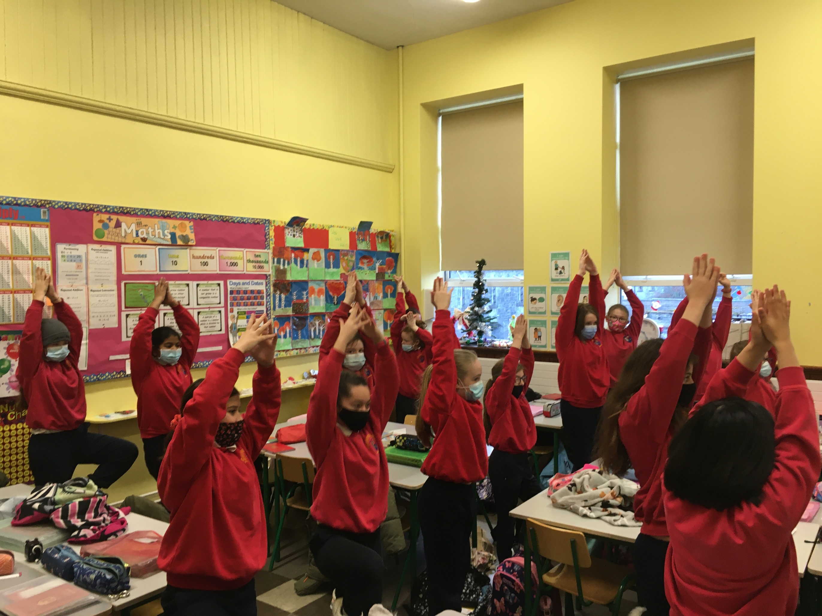
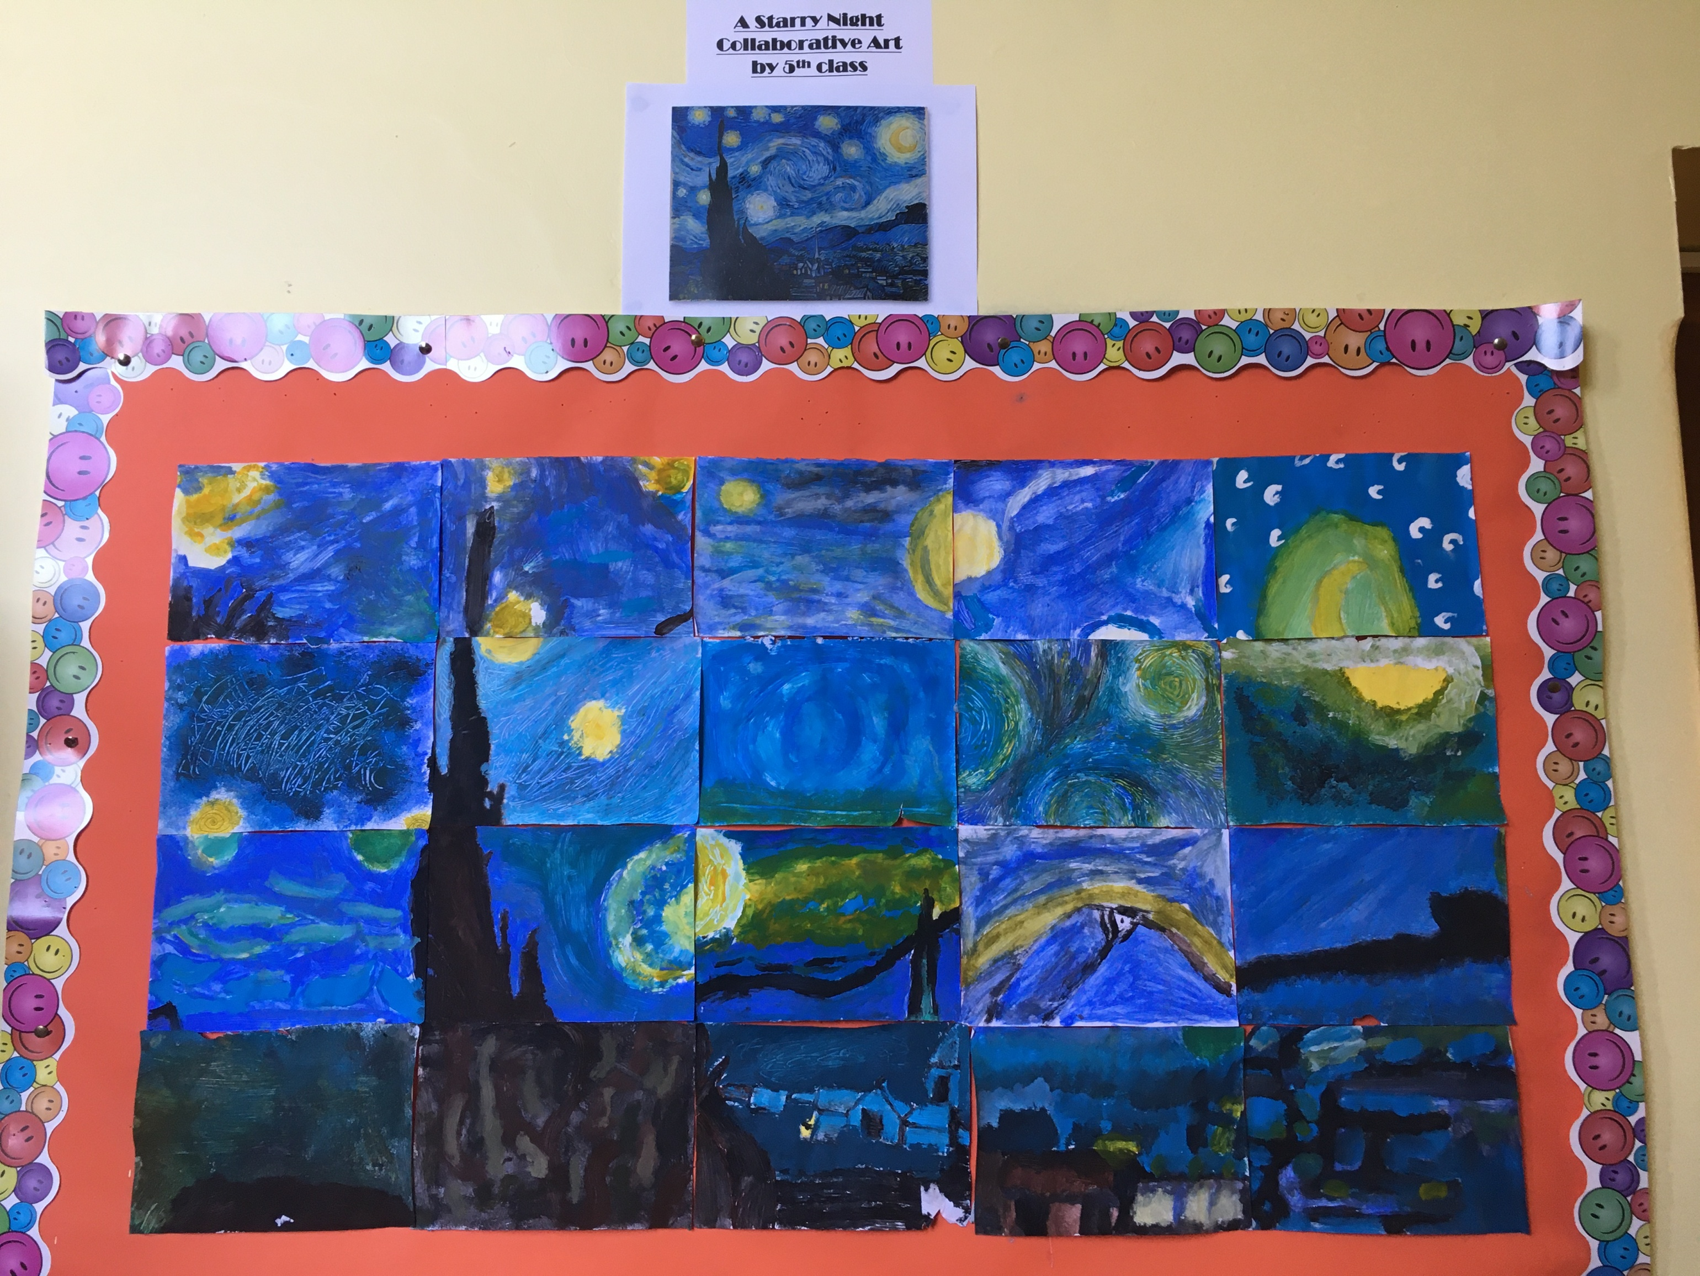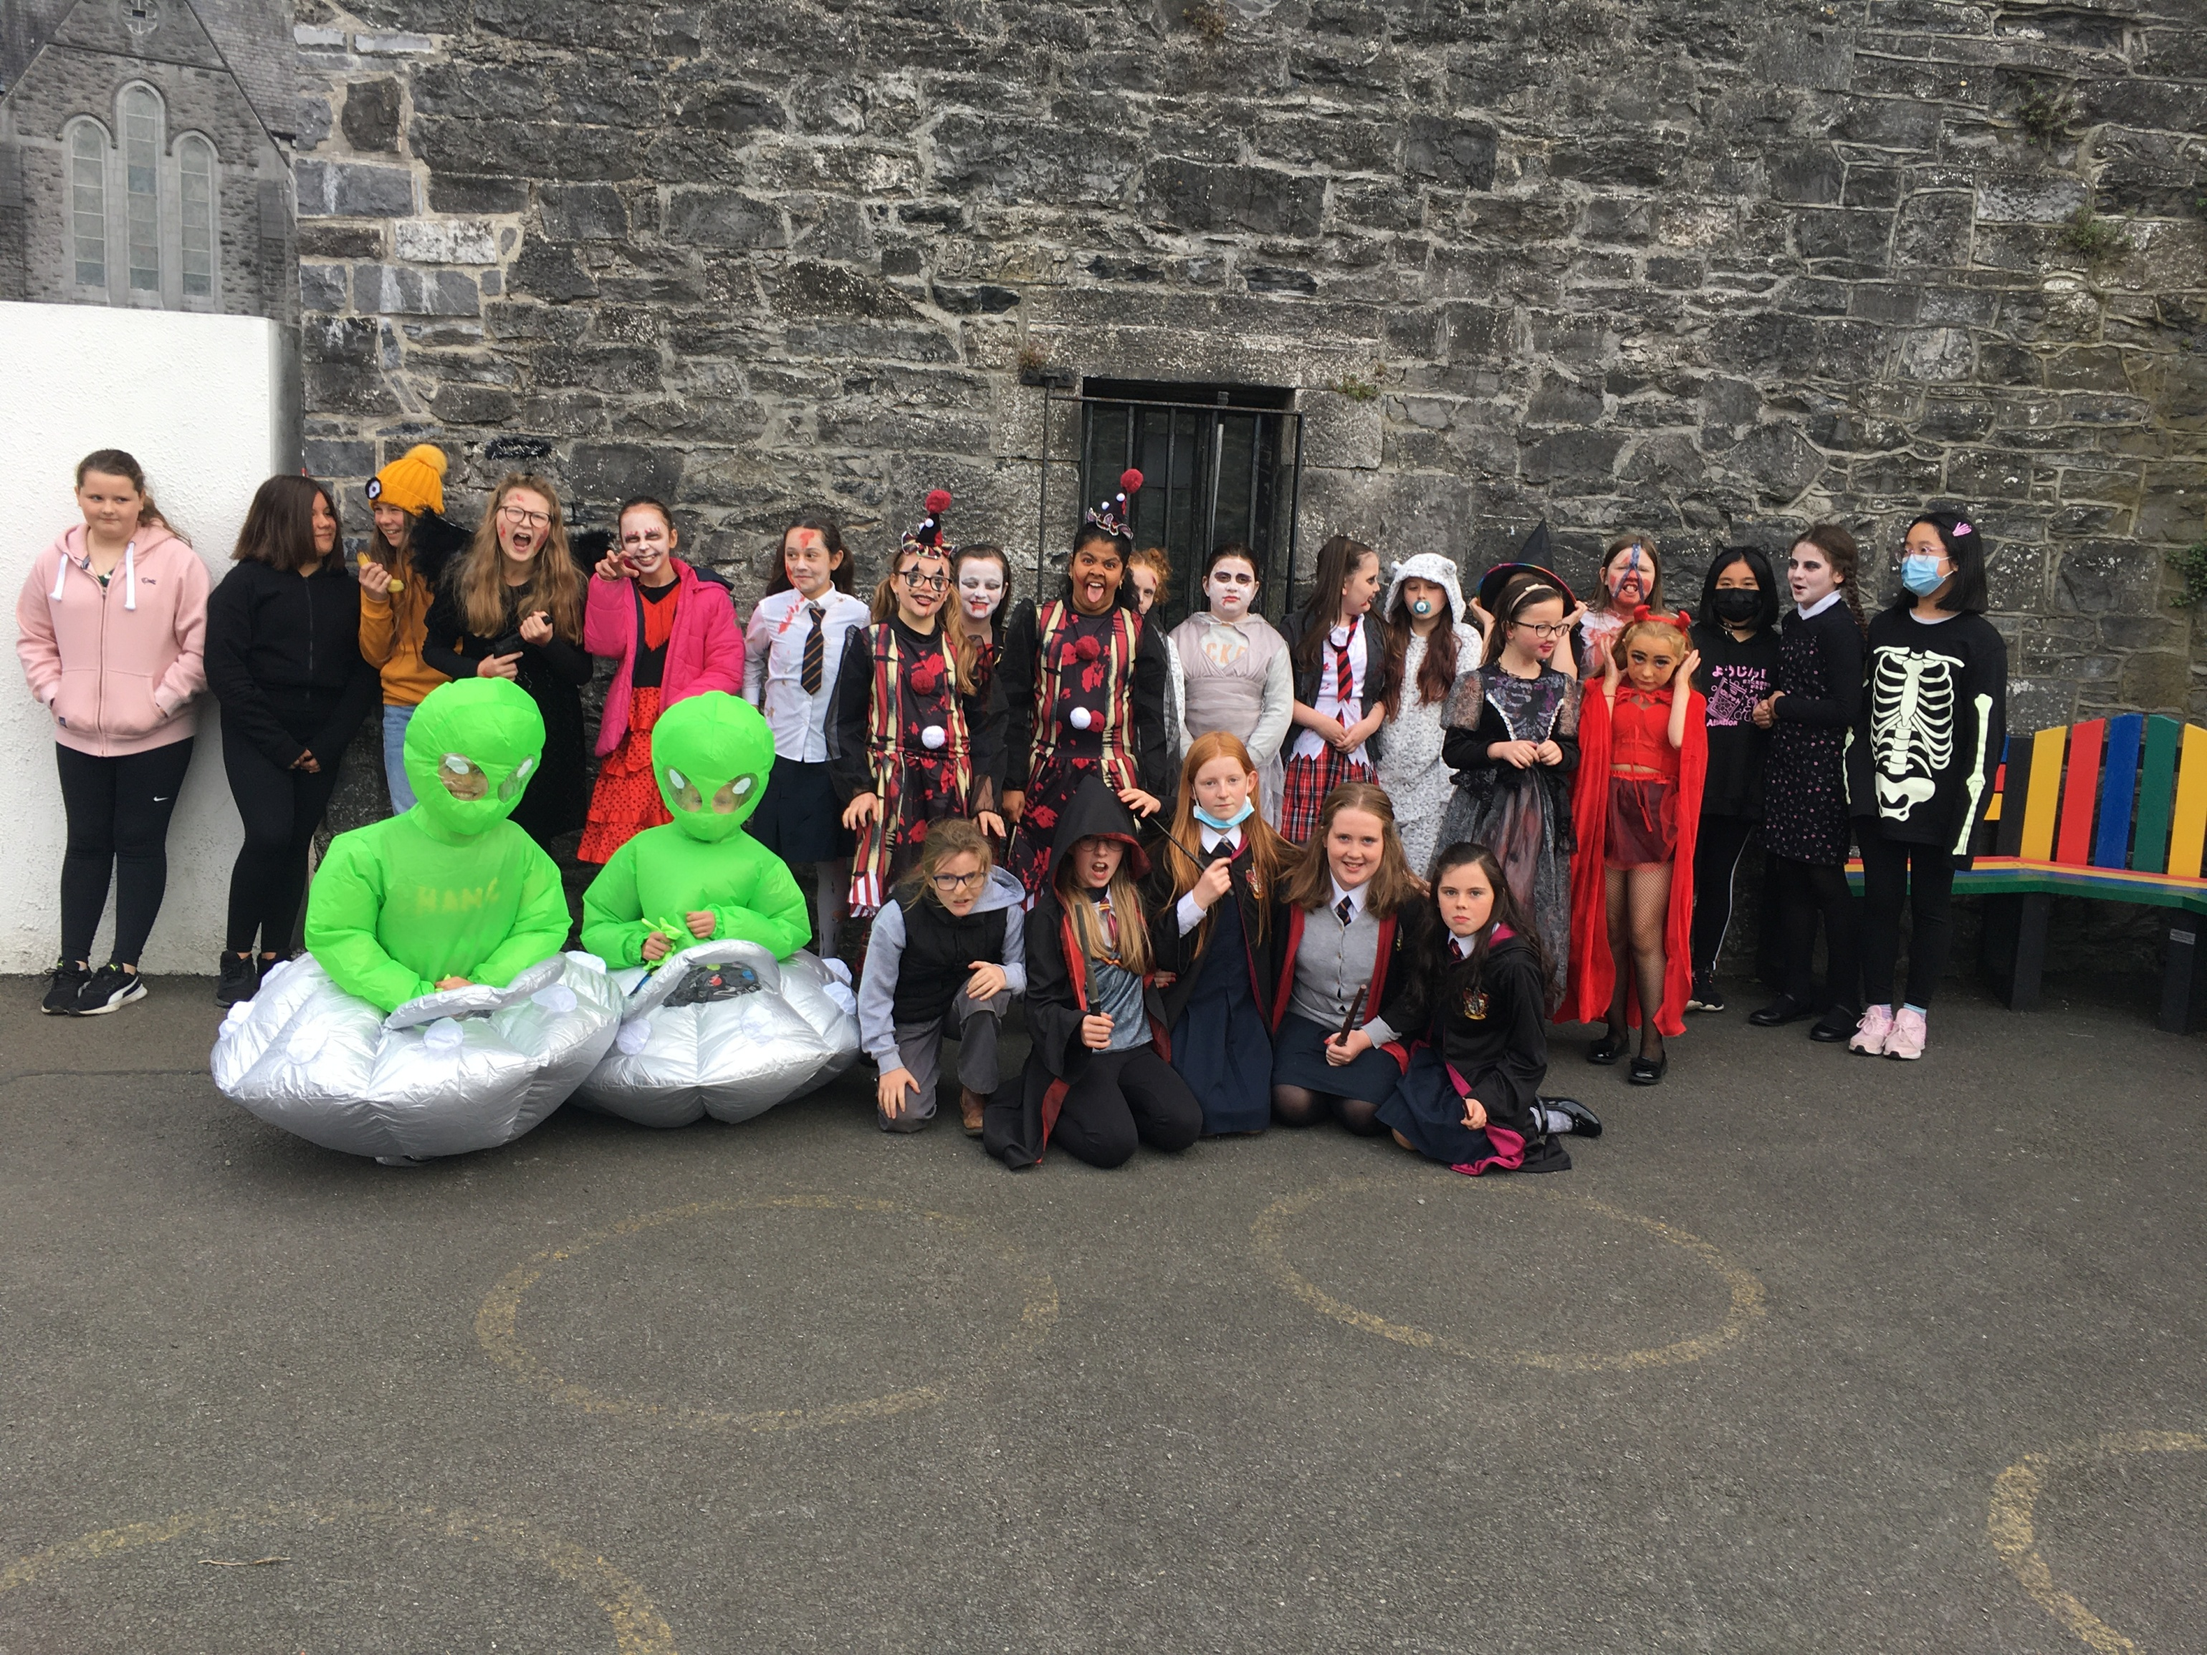

Ms. Fahy & Mrs. Kelly’s Second Classes
- This term has been very busy in Ms. Fahy’s and Mrs. Kelly’s 2ndclasses. We dressed up for Halloween, went a bit crazy for Crazy Hair Day, celebrated Mercy Day with Sr Joan and the other sisters, and took a walk to the convent to see the stained glass windows. Our classes have completed Literacy Liftoff this term and their reading has really benefitted. The girls trialled the Reading Eggs program and loved it so much that the school have purchased the program for 2nd classes for the year! They love going to the computer room to sign in to Reading Eggs as part of their Guided Reading - they learn all the skills of reading through fun games and activities. In our SESE we learned all about buildings – did you know our school is over 100 years old? Next week our classes are looking forward to exploring our new box of Irish games – we know the girls will love developing their Irish through the many fun activities there. Nollaig Shona Daoibh go léir ó Rang a dó!

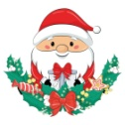
Mr. Shanahan’s Class
- Mr. Shanahan’s class have had a very busy term. Things were very scary on Halloween. The pupils also went on a trip to Tesco to buy bread and butter and jam so that they could make toast and jam. The class also went on an adventure to Nenagh castle. Here are some pictures of some of the exploits of the children.

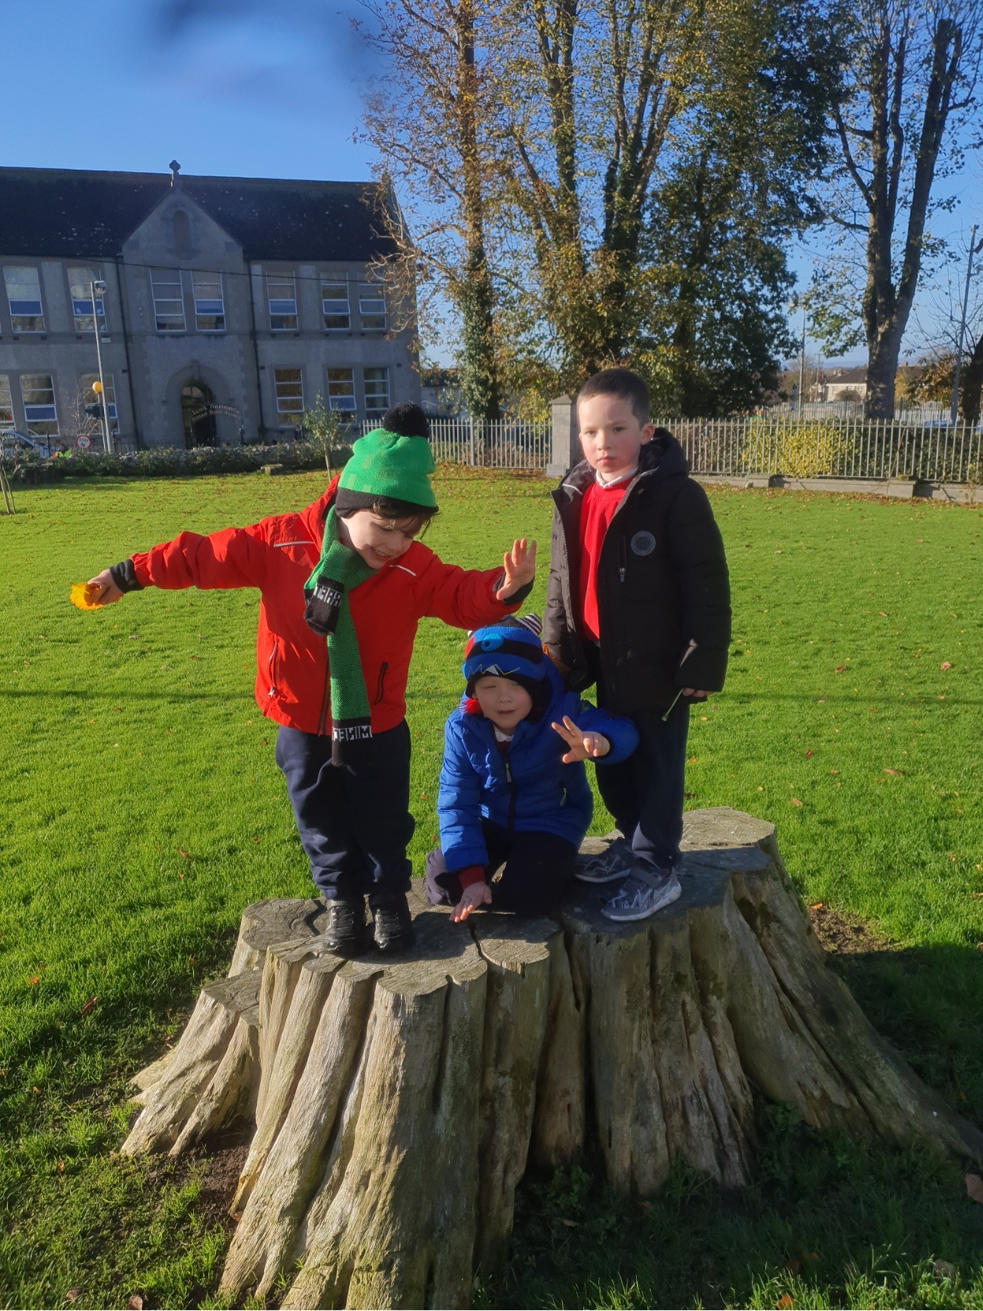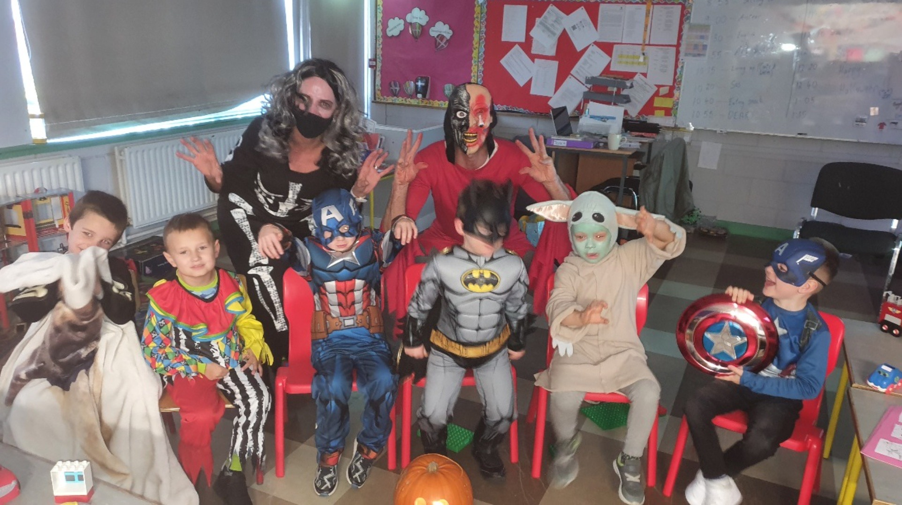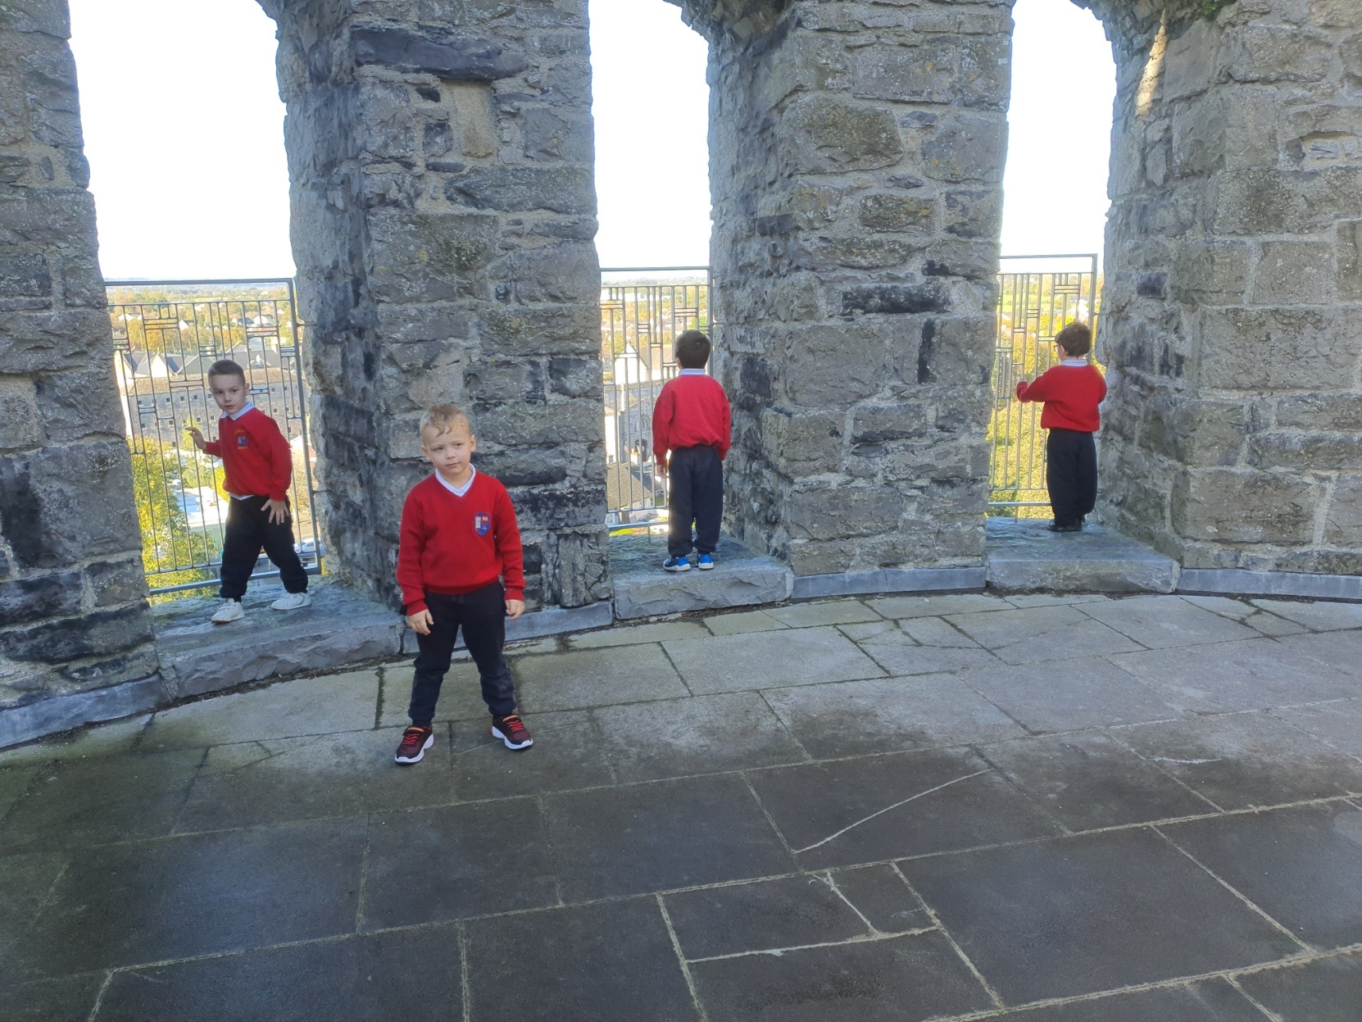

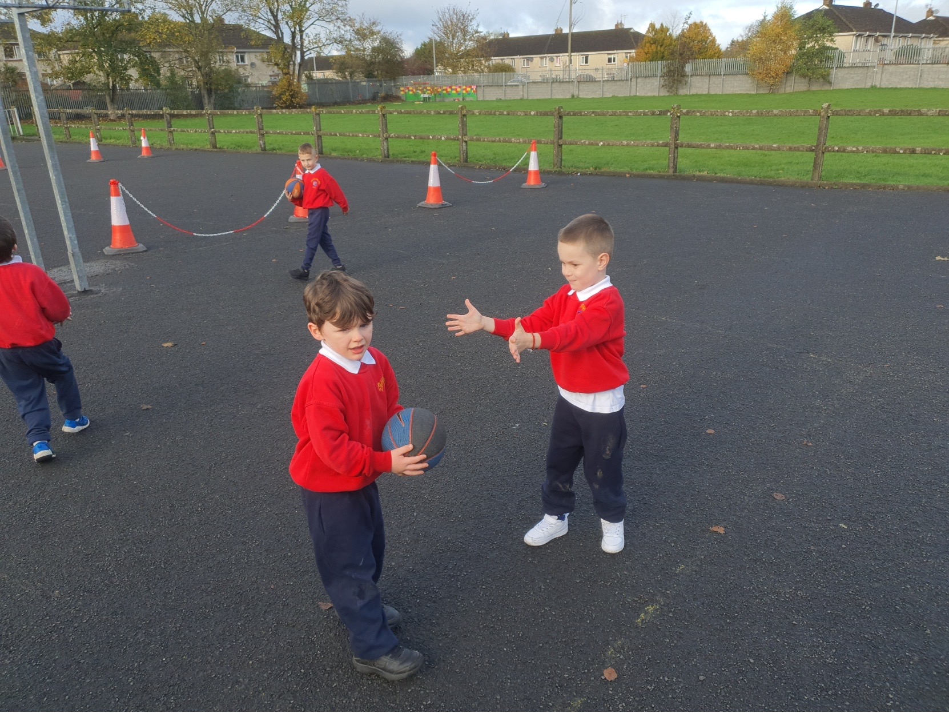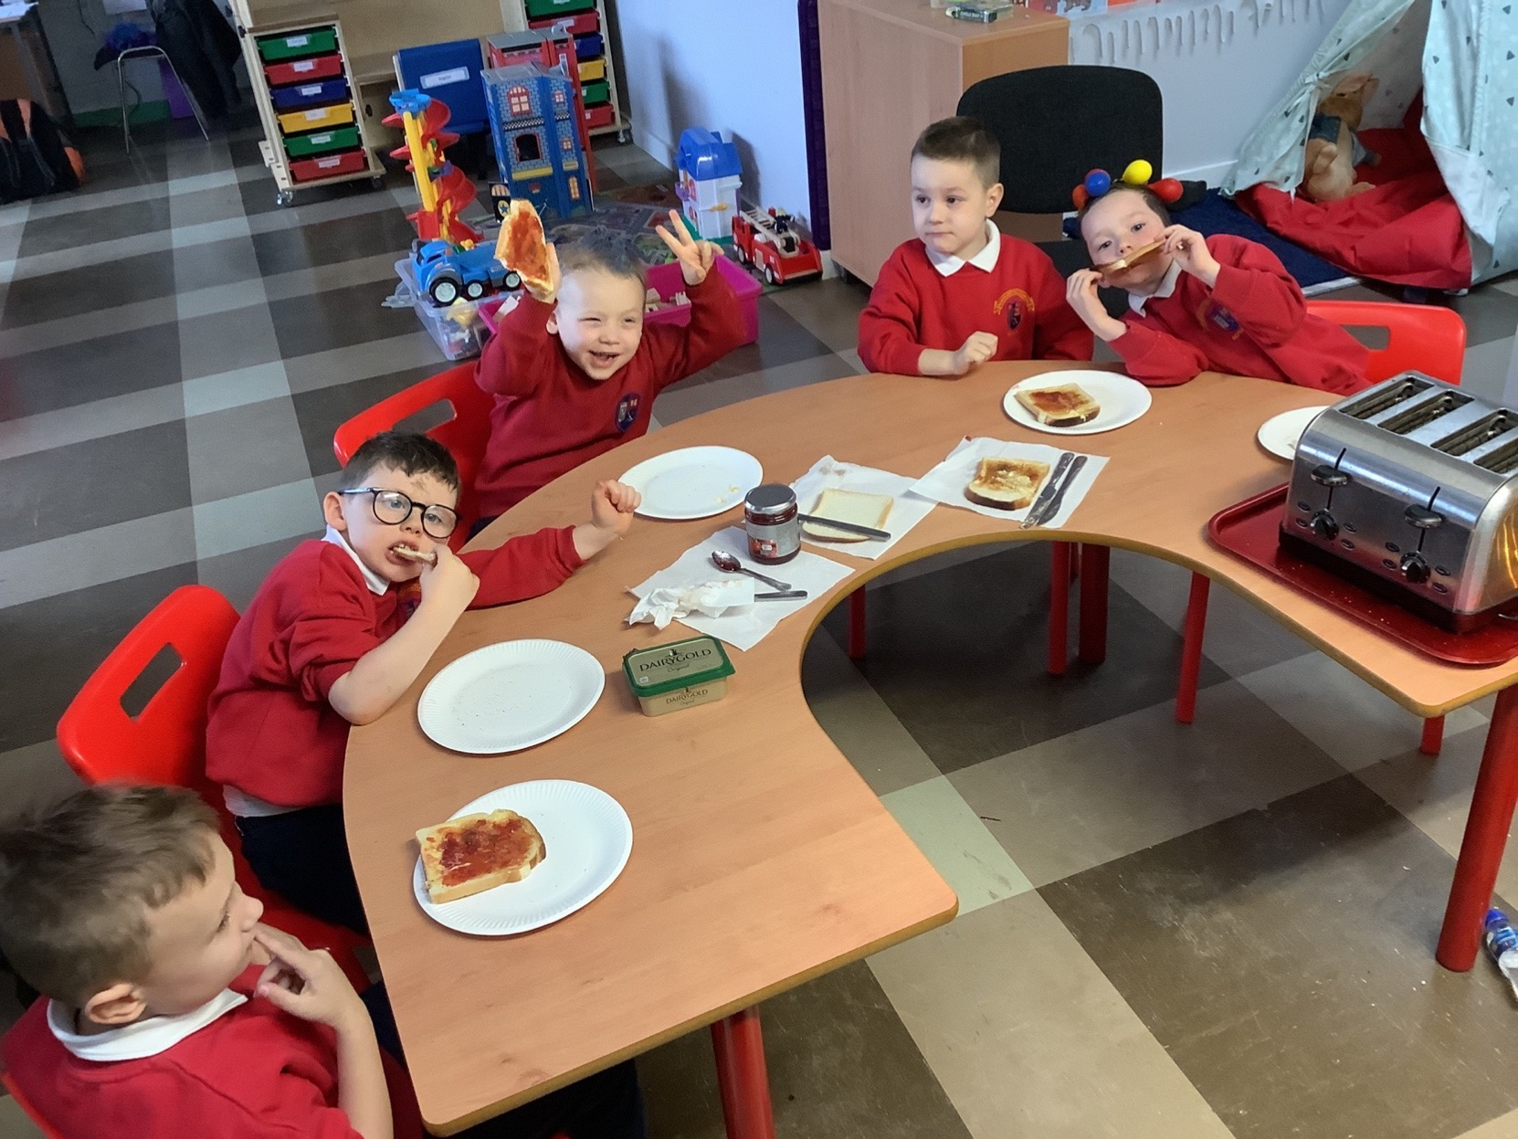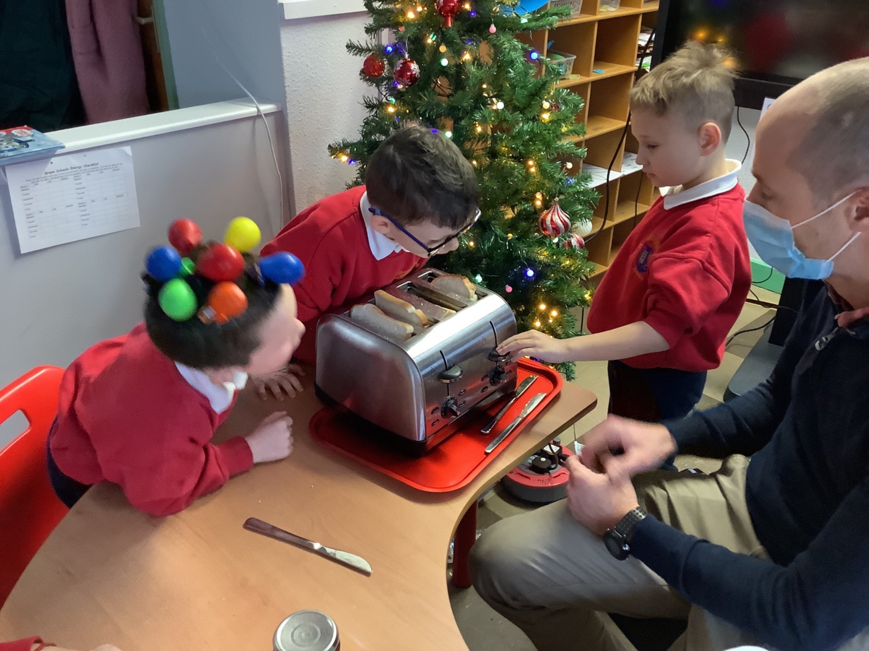

Ms. Máiréad’s & Ms. Cahill’s Senior Infants
- Senior Infants have done lots of work this term. We have been learning about how the post office works and the journey of a letter. We planted bulbs and are having fun taking care of them. We really enjoyed Crazy Hair Day and we loved making decorations for the Christmas Decoration Competition. Everybody who took part is a winner! We have been learning our Green Schools Slogan too ‘Don’t make a fuss, and go on the bus’. We are being very active in our classrooms too with daily movement breaks. Dancing is our favourite active activity. We are making some lovely clay stars to decorate our Christmas trees this week. Nollaig Shona Daoibh go léir!

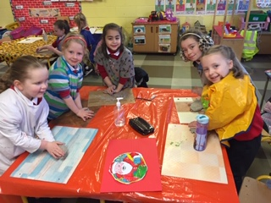 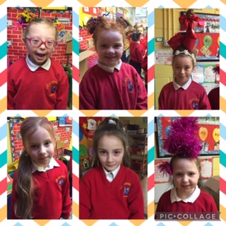 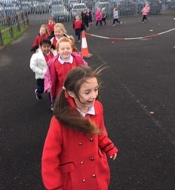Coding in Fifth & Sixth Classes
- Both 5th and 6th class took part in a coding programme this term with Pam O'Brien from TUS Thurles. The programme is run in conjuction with the Science Foundation of Ireland and teaches children about computer science, it enhances their knowledge of coding and develops their computational thinking. Having completed 8 weeks of the programme, the girls can now code their own computer games using the Makecode Arcade application.
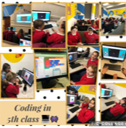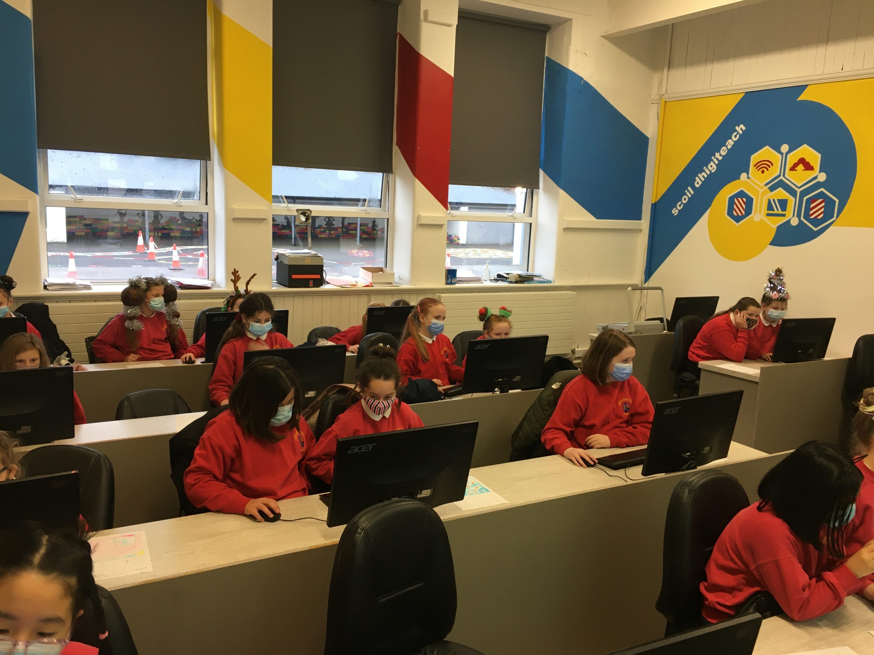

Ms. Mary Ryan’s Third Class.

- Here in Ms. Mary Ryan's Third class we have been busy following the GIY Grow at School programme! We are provided with a gardening plan that we can adapt to suit our own school garden and polytunnel area as well as video tutorials, resources and factsheets as an additional aid. We are currently in year four of the programme and it gets better each year with more opportunities for learning about organic planting, local biodiversity and nutrition. This year we have already harvested pumpkins and green beans from our polytunnel. In October we planted a native Irish cherry tree in our school grounds and in November we planted garlic bulbs and onions in our polytunnel. We look forward to caring for our vegetable patches throughout the next few months and harvesting them in late spring!
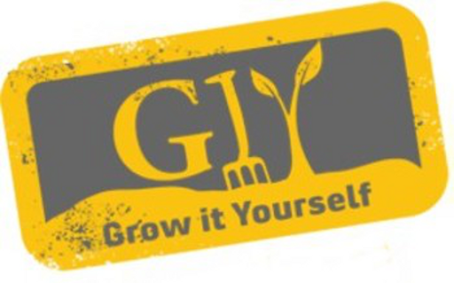
Thank you
Thank you to all of the parents/guardians of our pupils for all of your help in being so vigilant with your child/children when it comes to Covid 19. By working together, we have done well to curb the effect of Covid 19 on our school community. Let’s keep up this great work together.
Wishing you and your families a happy healthy and peaceful Christmas & New Year. School will reopen on Thursday January 6th 2022. We look forward to welcoming our pupils back then.

